

Learn How To Use WordPress

First edition 01.02.2013 by David Fonsbo

Content of this book

Content of this book 2
Legal Notice 3
Introduction 4
Prerequisites 5
Login to your WebSite 6
Basic Setup 7
Media/Add New 14
Comments 22
Appearance/Themes 24
Appearance/Widgets 26
Appearance/Menus 28
Plugins 31
Settings/General/Site Title 33
WordPress address (URL) and Site address (URL) 34
E-Mail Address 34
Membership 34
New User Default Role 34
Settings/Writing. 35
Press This 36
Post via e-mail 37
Ping services 38
Settings/Reading 39
Blog pages show at most 40
Syndication feeds show the most recent 40
For each article in a feed, show 40
Search Engine Visibility 40
Setings/Discussion 41
Quick Edit 43
Contact 44
Resources 45
Other products by me 46

Legal Notice

The Publisher has strived to be as accurate and complete as possible in the creation of this report, notwithstanding the fact that he does not warrant or represent at any time that the contents within are accurate due to the rapidly changing nature of the Internet.

While all attempts have been made to verify information provided in this publication, the Publisher assumes no responsibility for errors, omissions, or contrary interpretation of the subject matter herein. Any perceived slights of specific persons, peoples, or organizations are unintentional.

In practical advice books, like anything else in life, there are no guarantees of income or any other results made. Readers are cautioned to rely on their own judgment about their individual circumstances to act accordingly. Think for yourself.

This book is not intended for use as a source of legal, business, accounting or financial advice. All readers are advised to seek services of competent professionals in legal, business, accounting, and finance field.

In short: Use your common sense and your brain.

You are encouraged to print this book for easy reading, but you cannot copy, redistribute or sell this ebook. Neither in whole nor detail.

Introduction

Thank you for downloading The Simple WordPress Installation Guide!

WordPress has become a very widely known and used Content Management System for web sites. It is free and easy to use and with the information in this book you can create your own web site.

WordPress is easy to use. It handles text and images very easy and if you want to optimize for searchengines WordPres is definitely the way to go!

You can find tons of templates for WordPress on the web. This means you can completely redesign Your site in less that a minute!

In this guide you will learn:

- How to set up WordPress in the best possible way to get started.
- How to create posts and pages.
- How to add images.
- How to use templates (themes)
- How to handle comments on your blog.
- How to add users/authors to your site.
- How to install plugins
- User registration

Prerequisites

Before we get started you wll need:
- A server to host your WordPress installation. You can buy hosting all over the net or you can make your own Apache server based on Windows or Linux etc.
- A domain name – You can buy the all over the net too.
- A working WordPress installation. Download your free ebook, SimpleWordPressInstallation. at www.TotalWordPressOptimization.com.

Login to your WebSite

When you login to WordPress you can do it by entering your sitename in your browser followed by “wp-admin”:

Like this: www.YourDomain.com/wp-admin

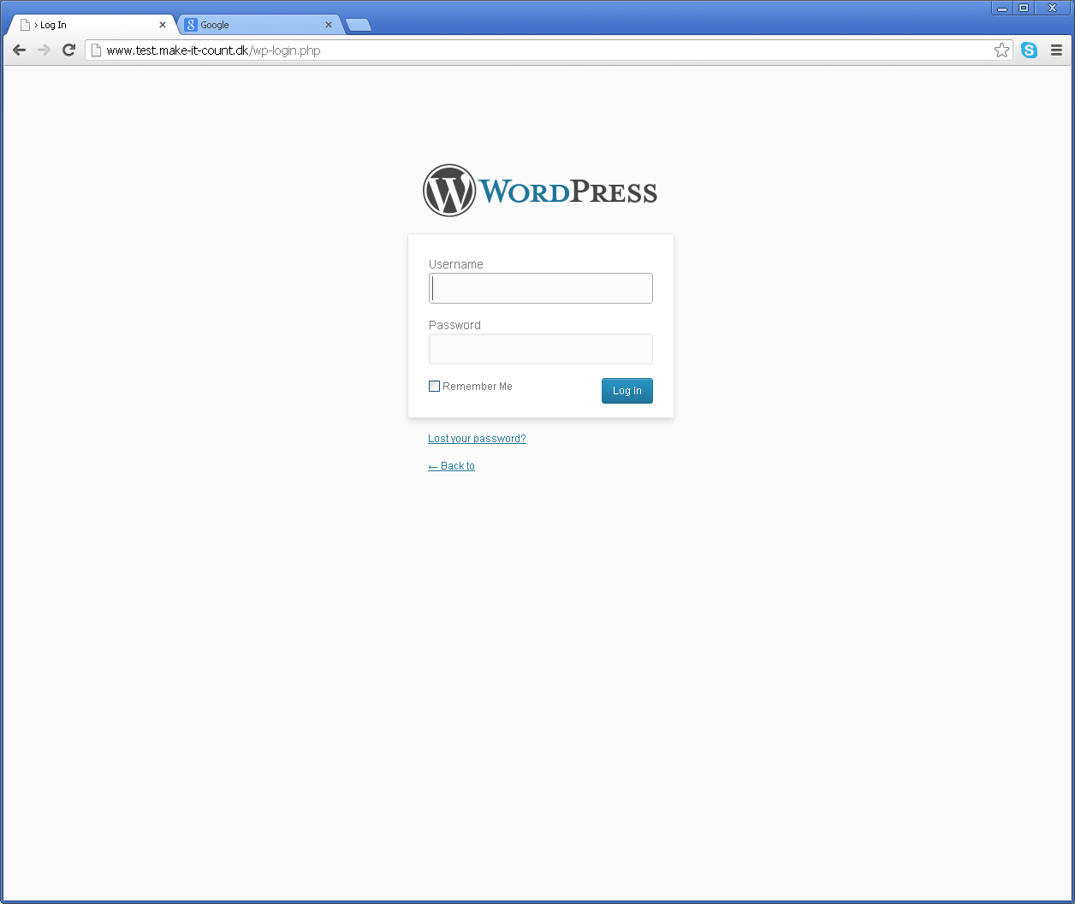
At the time WordPress was installed, you (or who ever installed it) was asked to enter a username and a password. These two things are what you need to enter now.

Basic Setup

This is how WordPress looks from inside. This is the WordPress Main Control Panel (or Admin Panel).

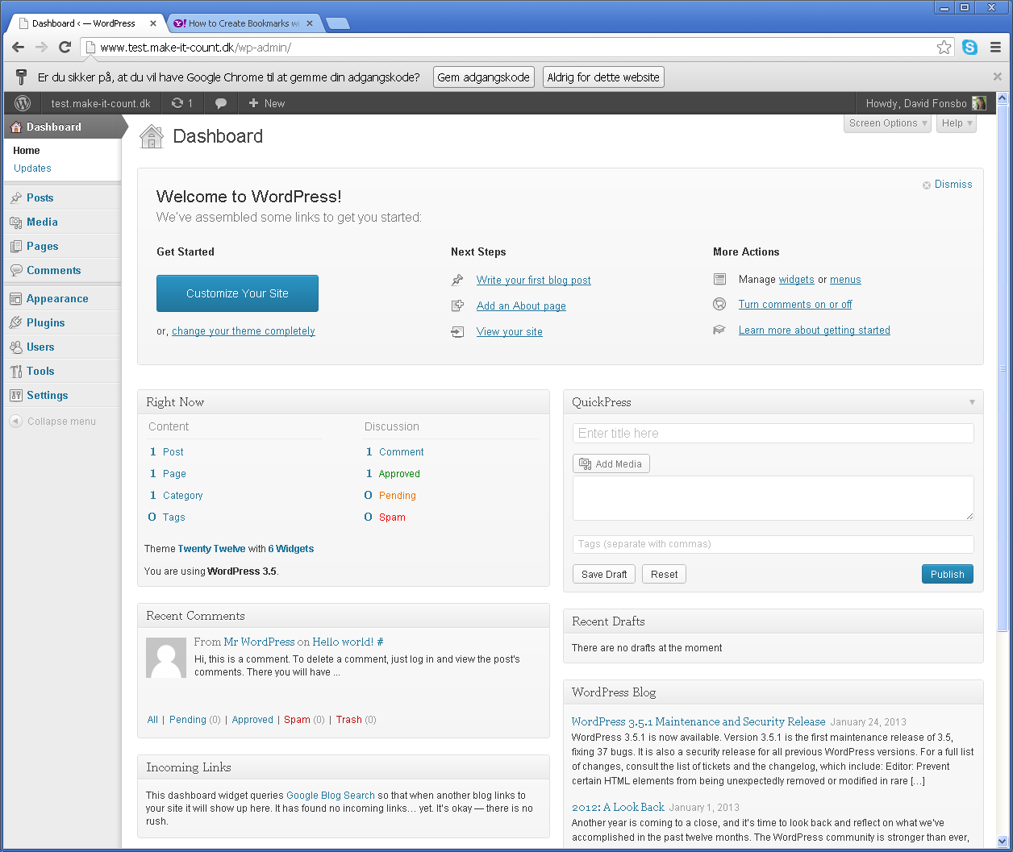
Normally you will setup WordPress before you start publishing Posts and Pages, but in this particular case we will create a few Posts, a Page and some categories first. This is only to make the next steps more clear.

The difference between posts and pages is that all posts are put on one page. The newest usually above the others. This is great for blogging. Click Posts and take a look at the post “Hello World”.

You can see the result by opening a browser and enter your homepage URL.

A Page is usually used for more static content (About pages, product info, Company info etc.). If you take a look at your new site “Home” is your blog (Posts) and “Sample Page” is a Page. Posts and Pages can be created and edited from the main WordPress Control Panel – The first window you saw when you first logged in to your site.

For now we will create two Categories, one Post and one Page.

First we create the Categories. Go to WordPress Admin panel – the first screen you see when you log in. From the Menu on the left select Posts and click Categories.

Find the text where it says: Add New Category. Beneath this text it says Name. In this box type the name of your category. It could be Boats or if you are writing about horses then call it “horses”.

If you are SEO fanatic you research your categories (keyword analysis) to see if they will give you any visitors (more on this in the e-book TotalWordPressOptimization) and then you use the “Slug” to control your URL (“www.YourSite.com/horses” or “www.YourSite.com/horses/shetland-pony”). Use only letters, numbers and hyphens.

Remember to scroll down and click Add New Category when you are finished.

Create a Post:
Go to WordPress Admin panel. From the Menu on the left select Posts. On the top of the page click Add New:

And you get an editor looking somewhat like this – note that some plugins will change the look of this page by adding text and more boxes:

Type in anything you want and click Publish. Your Blog Post is now on the Web!

The details on the right:

If you click Save Draft your Post will only be saved – not published.
You can password protect your post here: Visibility: Public Edit.
And you can plan your publishing ahead by clicking Edit at: Publish immediately. Here you can set a specific date and time to publish.

You can select a Category to the right where it says Categories.

Tags are like categories, but more specific. You don't have to use tags, it is completely optional.

It is that simple to create a Post! Now we will ad a Page. Depending on your theme tags can be displayed somewhere on your post. Top or bottom or maybe in the sidebar.

Create a Page:
Go to WordPress Admin panel – the first screen you see when you log in. From the Menu on the left select Page. On the top of the page click Add New. From here the procedure is the same as when we created a post.

Quick Edit

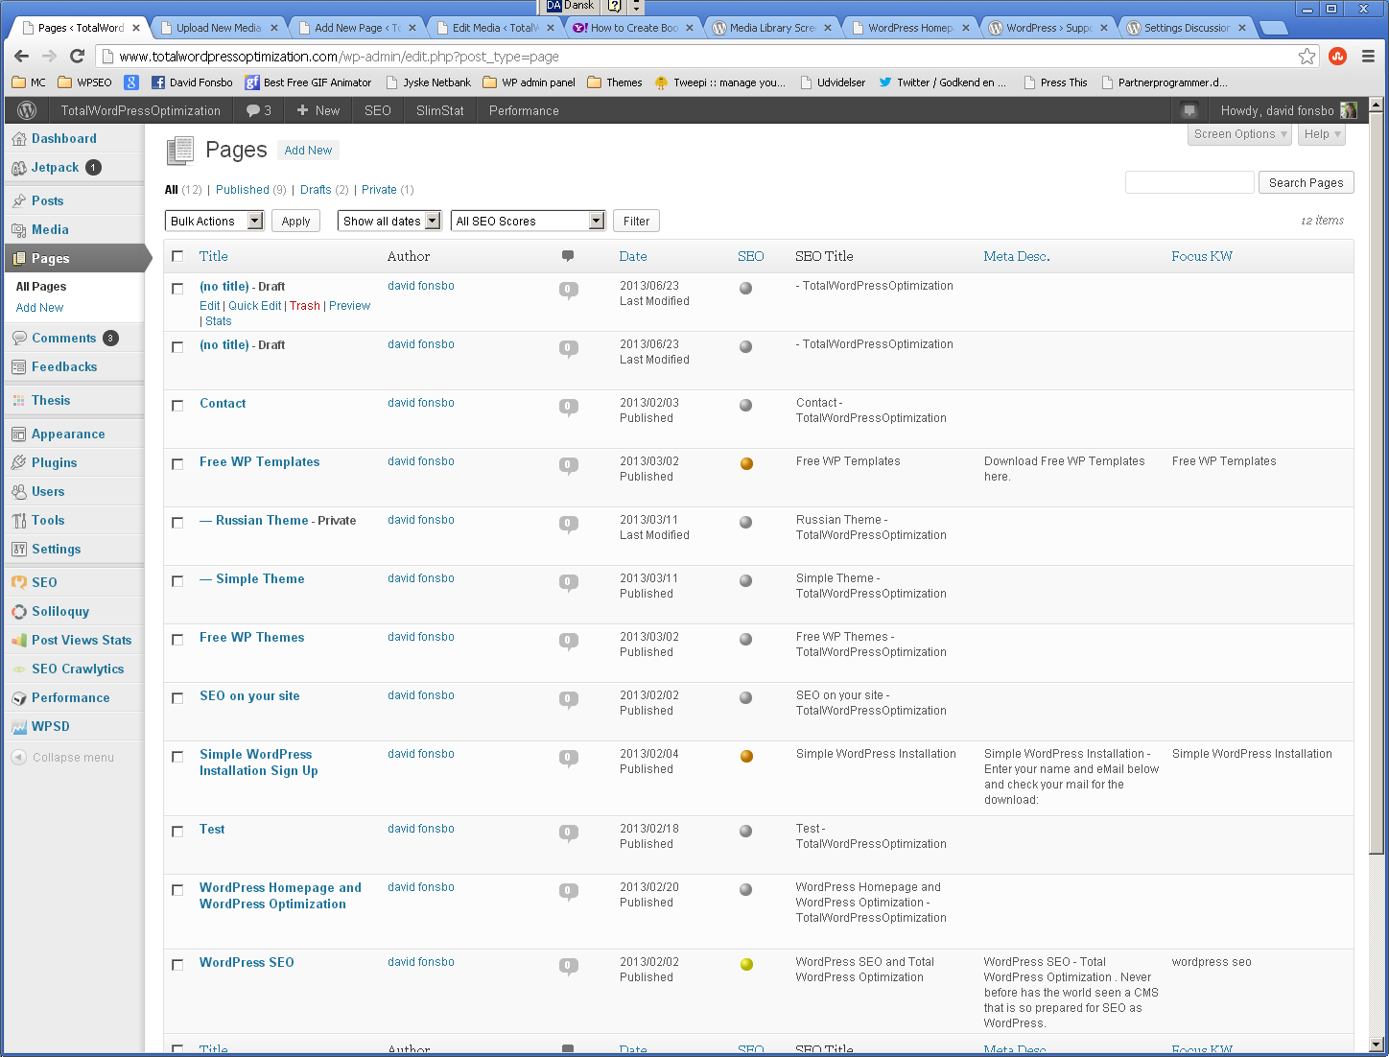
When you click “Posts” or “Pages” and hover your mouse over the list of posts you will see a smart thing popping up under the mouse (the green circle).
Click Quick Edit and a menu will unfold. Her you can override your comment settings. If you disallow comments here it will not be possible to enter comments.
You can also set password on your article, change Title and Slug (internal Wordpress Title which becomes tha last part of the URL).
You can also direct your article directly to Trash from where it can be restored within 30 days. You can also do this when editing Posts and Pages.

Media/Add New

Here you upload images, video, audio and other files which are inserted in to Posts and Pages.

It is vey easy. You simply drag and drop your files where it says Drop files here or you can browse your computer for mediafiles.

When uploading has finished you click Edit.

If you prepare your Media files for SEO enter Title, Caption, Alternative Text and a description. Google cannot read images yet and the only way to tell Google about your media is to give images a description.

Give your Media a Title. Here the Title is “adwords”. Be more specific than that! If you are building your articles around great keywords this would be the place to use that keyword.

Caption is a very short description.

Alternative text is displayed if your browser can't handle this media file.

Also enter a more descriptive text in the editorbox.

The Title attribute is displayed when hovering your mouse over the image. The Title attribute cannot be entered here. You have to do this when you create your Post.

Inserting a media file in your Post or Page.

Create a new Page or post or select an existing. Click Add Media:

Select an image to insert:

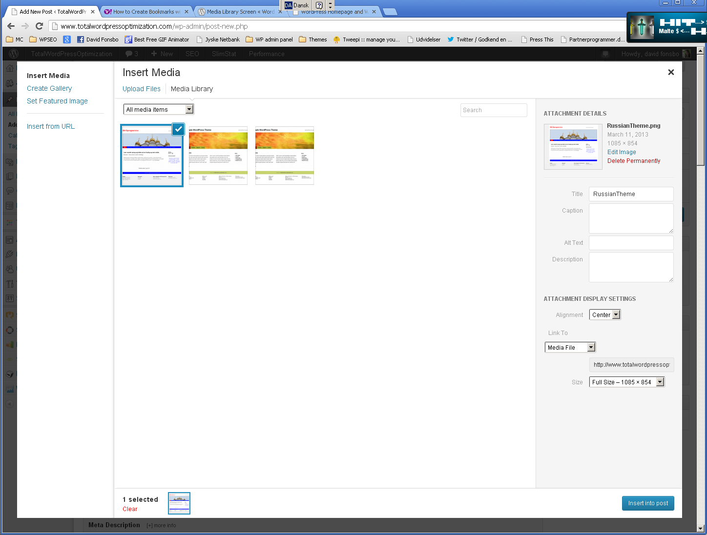
And click the blue button “Insert into post”

Editors in WordPress are different. Here I'm using the standard editor. If you click on the image it turns blue and two icons are displayed. Click at the one in the green circle above.

Fill in the blanks and click the tab Advanced Settings:

Adjust the size to your Post/Page using the Size Width and Height. Click Update when finished and remember to click Publish when you are finished composing your Post or Page.

Comments

From time to time you will notice that somebody comments on your postings. Unfortunately many of these posts are spam caused by people who wants better rankings in Google by having a link from your site pointing to their salespage. In the e-books TotalWordPressOptimization and WordPressSecurity we will deal with spam). Some of the comments might also be from real people. If someone are referring directly to what you blogged about the author is likely to be real. If the comment is general and would fit into any blog and especially if there is a link to another website, it just might be from a robot.

Click in the box on the left side of any post and select the drop down where it says: Bulk Actions. Select Approve if you want the comment displayed under your post or select Mark as Spam if you suspect it is an automated posting.

Appearance/Themes

Then try clicking Appearance from the Admin Menu.

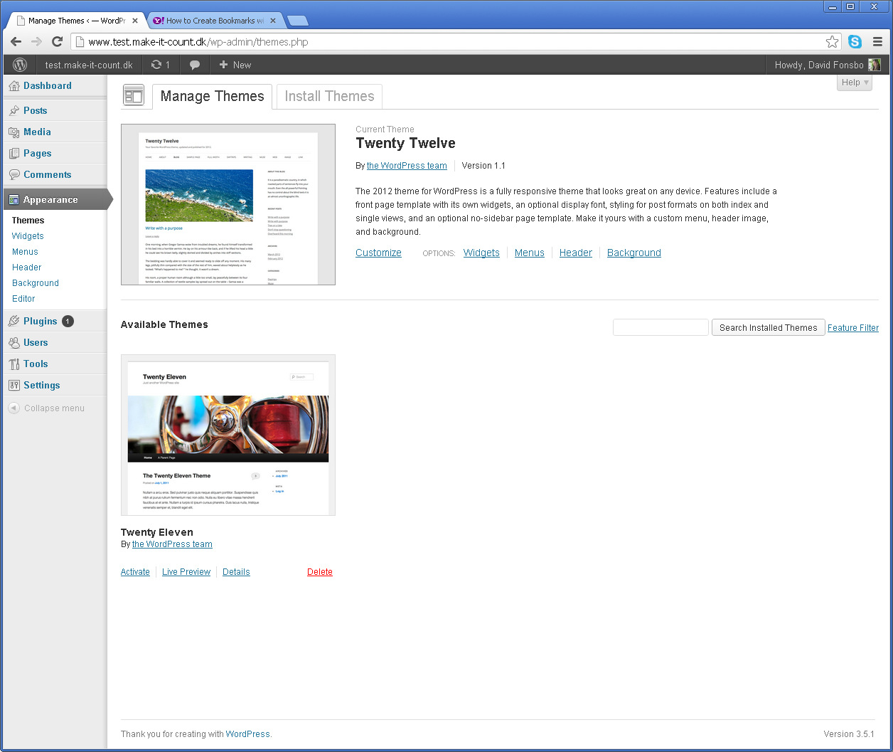
Here you can select the basic appearance of your site. You have two default templates and you can search for and install many more by clicking the tab “Install Themes”.

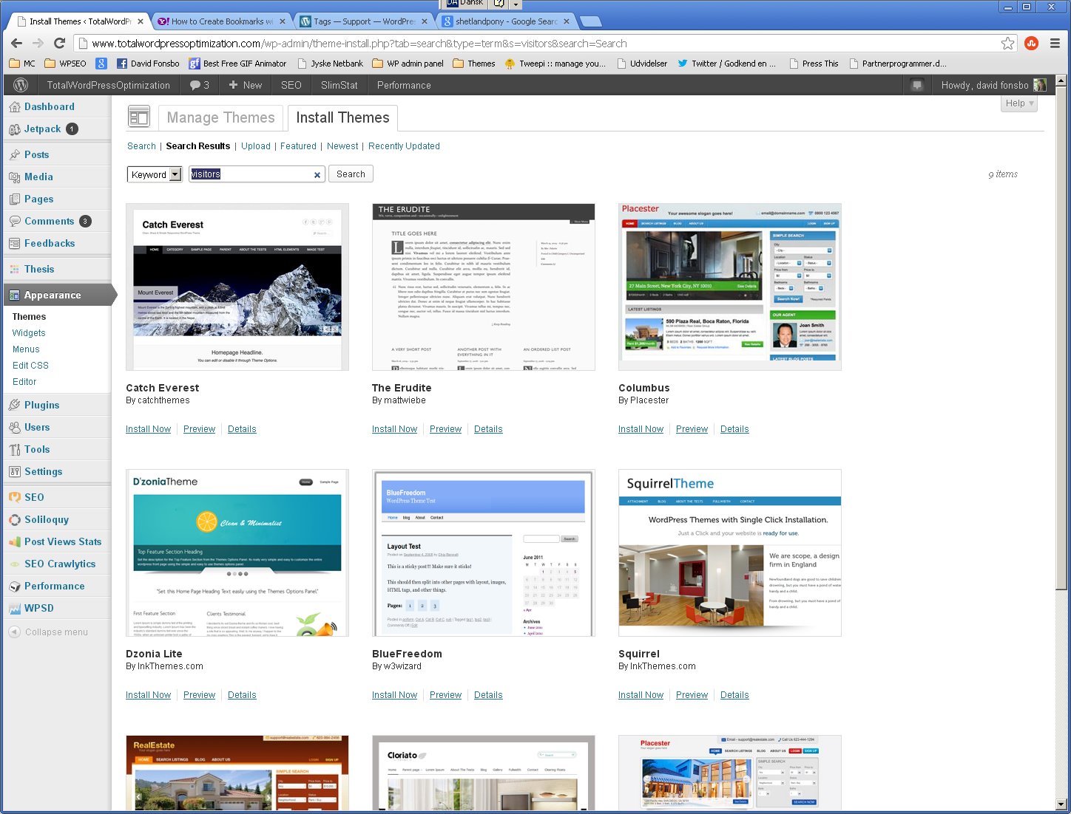
Enter your search criteria and click Find Themes. You will get a preview list of all the templates in the WordPress repository that meets your search criteria. When you find one you like you simply click Install Now (Under the preview image).

Appearance/Widgets

Widgets are small boxes you can drag and drop in to the sidebars. Calendars, Tag rotators, Newsmail signup, Stats, Social Media connection, and much, much more. A lot of plugins actually install widgets so when you install plugins check the widgets. It is extremely easy. Just drag and drop. The widget will open if there is anything for you to do.

If you want to remove widgets just drag them back to “Available Widgets” (where they originally are placed) EXCEPT if there are data in the widgets you want to preserve. Then you drag them to the bottom of the page where it says “Inactive Widgets”.

Appearance/Menus

Menus are important for navigating. If anything goes wrong or is acting strange then check you have selected the menu here:

The building of the menu is very simple. You can use:

Custom Links
Pages
Categories
Posts

Some plugins may add stuff that can be used in menus.

Look for the tabs that says: Most Recent – View All – Search. I suggest you click View All. Otherwise you can look for a long time after something you have written and want placed in the menu.

Create a menu by clicking at the tab with a “+”. Enter a menu name and click Create Menu. You can create multiple menus and select which one you design by clicking on the Menu Tabs (green circle).

In the boxes on the left you simply select which articlec you want in your menu and then you click Add to Menu – And remember to click: Save Menu! The menu would look something like this. Note that you can create submenus simply by dragging menus to the right as here on the image (Simple Theme is a submenu under Free WP templates)

Plugins

It is very simple to install plugins. Of course you need to find the right plugin first. Click Plugins from the Admin Menu and select Add New. If you are looking for SEO plugins simply enter “SEO” and click Search Plugins.

Here is your search results. Look at the star ratings and the descriptions and install the plugin you want simply by clicking Install Now.

Notice that when a plugin has been installed it says: “Installed” instead of “Install Now”.

Settings/General/Site Title

First go to Settings - General in the Admin Menu at the left and check Your Site Title and Tagline (short description). Give your site a Title, a short description and save the changes. Your Title and the Tag line will be shown at the top of your pages (in most templates) and they are also used by the searchengines to index your site. So they are pretty important!

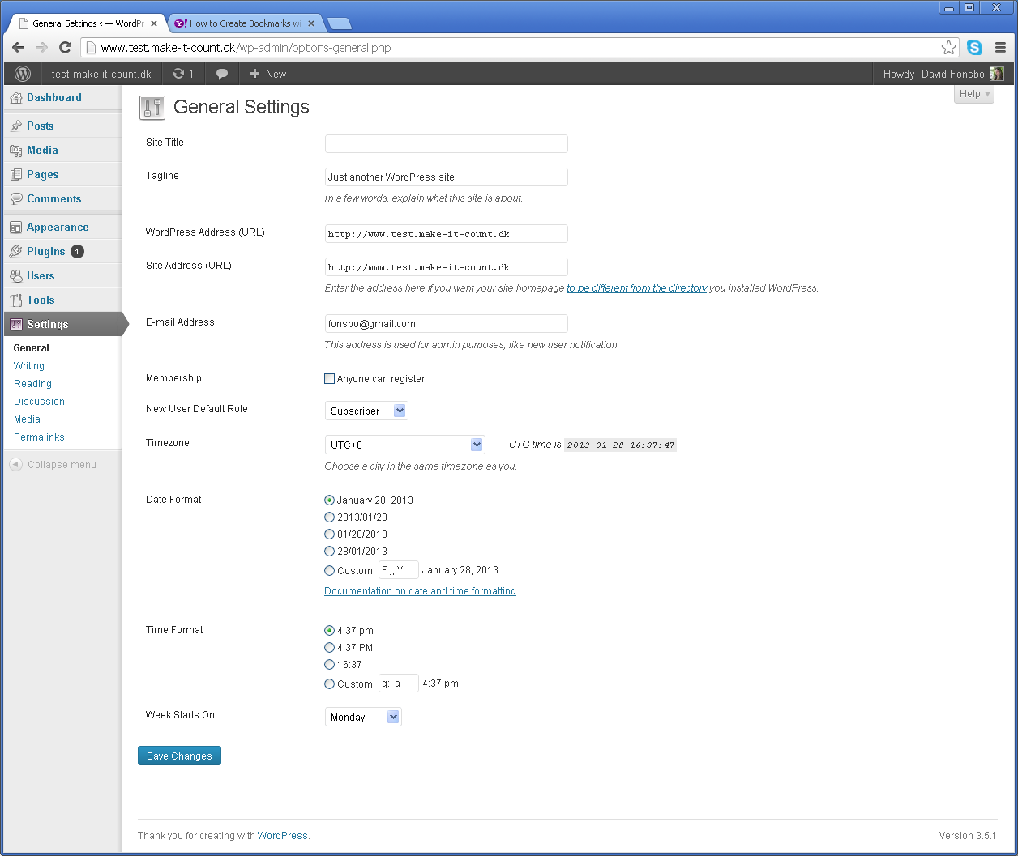

WordPress address (URL) and Site address (URL)

On this page there are two fields named "WordPress address (URL)" and "Site address (URL)". These are also known as the "Home" and "Site URL" settings.

The "Home" setting is the address you want people to type in their browser to see your WordPress blog.

The "Site URL" setting is the address where your WordPress core files reside.

Both settings should start with “http://” and no slash “/” at the end.

E-Mail Address
is where your email is entered. When someone comments on your blog you can have notifications sent at this address.

Membership
is used if people can register at your site. Normally this box is empty if you don't want everybody to register. If you want people to register check the box and use “New User Default Role” to decide what status people will get when they sign up.

New User Default Role
There can be various reasons for people to sign up. Maybe you have 25 people writing articles for you or maybe you have a web master who has to be able to log in. Setting “New User Default Role” to Admin” would be a bad idea! If you don't want anybody to register just leve it at “Subscriber”. If you are trying to get 25 article writers to register you can use Editor.

- Super Admin: somebody with access to the site network administration features and all other features. This is only for Multi Blog installation. See the Create a Network article at WordPress Codex.

- Administrator: somebody who has access to all the administration features within a single site.

- Editor: somebody who can publish and manage posts including the posts of other users.

- Author: somebody who can publish and manage their own posts.

- Contributor: somebody who can write and manage their own posts but cannot publish them.

- Subscriber: somebody who can only manage their profile.

And you can change your Time Zone and Timeformat at the bottom of the page and REMEMBER to click Save when done!

Settings/Writing.

Decide if you want WordPress to convert emoticons “:-)” to graphics.

If you are using your editor in normal text mode this switch has no effect, but if you are coding your own (x)html it would be a good idea to ask WordPress to check the code for you. Turning this on can conflict with some plugins!

When you create a new post WordPress will suggest what ever you have chosen (the red circle). Select the Category you want to be the default Category in the drop down box “Default Post Category”.
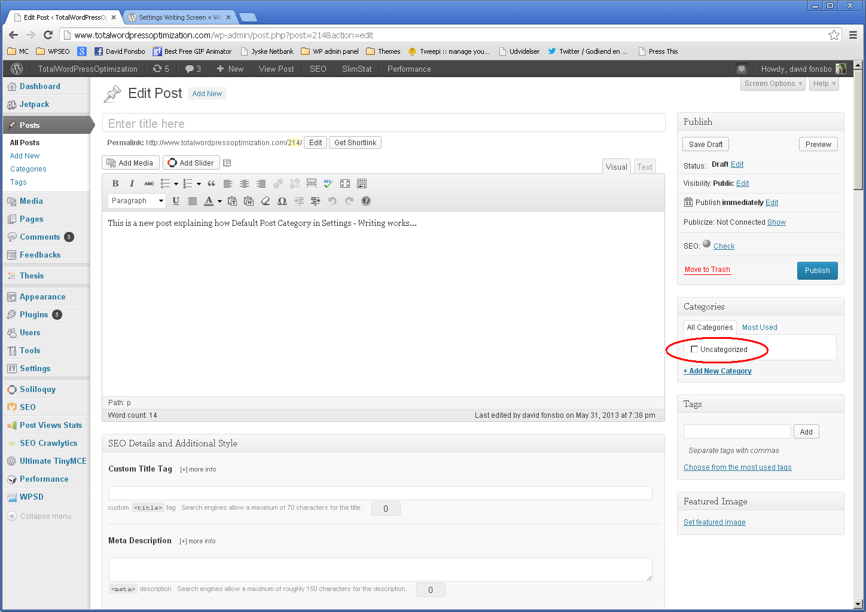

Press This
“Press This” is a little app. Drag the Icon to yourBookMark bar:

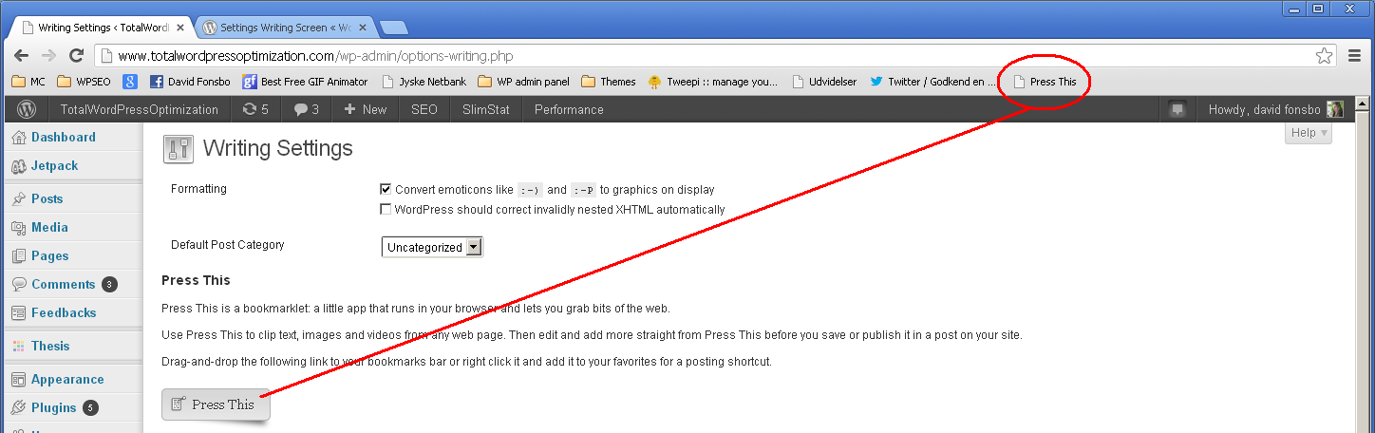
When ever you find something interesting on the net you want to blog about just click “Press It” and up comes the wordPress editor and you can start editing and publishing right away!

Post via e-mail
Posting by mail. Remember to use plain text. HTML mails will not work.

Create a secret mail account with no other purpose than receiving posts for your WordPress blog.

Enter this (for gmail) in Mail Server: pop.gmail.com
Port 995.

Enter your login name (YourName@gmail.com and your password.

Select which category WordPress should use when publishing your mail.

Do this in Gmail: Go to Settings. Click the tab: “Forwarding and POP/IMAP” and enable the “Enable POP for all mail.

Create a filter (in Gmail) that deletes all mails not sent from you. Go to “Filters” and “Create new filter”. In the “From” field input your email address and add a hyphen in front of it. Example: –youremail@domain.com. Then click “Create filter with this search.” Tick the “Delete it” checkbox, and click “create filter.”

Now you are ready to send mails which your WordPress installation will publish.

Ping services

It is a great idea to ping a bunch of relevant servers when writing new articles, but it has to be controlled. Yoast Wordpress SEO will automatically ping google and Bing and you can set it to Ping Yahoo and Ask.com also.

In the WordPress admin menu click Settings and take a look at the bottom of the page where it says Update Services.

Here is a short list of services you can ping. They will be pinged when ever you create or change an article.

http://rpc.pingomatic.com
http://www.blogpeople.net/servlet/weblogUpdates
http://ping.myblog.jp
http://ping.bloggers.jp/rpc/
http://bblog.com/ping.php
http://ping.feedburner.com

Pinging these services provides more exposure.

Go to: http://codex.wordpress.org/Update_Services and read more about Ping Services. They also have a list of servers you can copy/paste in to the Pinger plugin.

You can find a lot of ping service lists on the net. Pingomatic.com is a key service to ping as it pings other services: www.Pingomatic.com.

Settings/Reading

In Settings/ reading you can select what should be your front (Home) page. It can be your blogposts or it can be a static page:

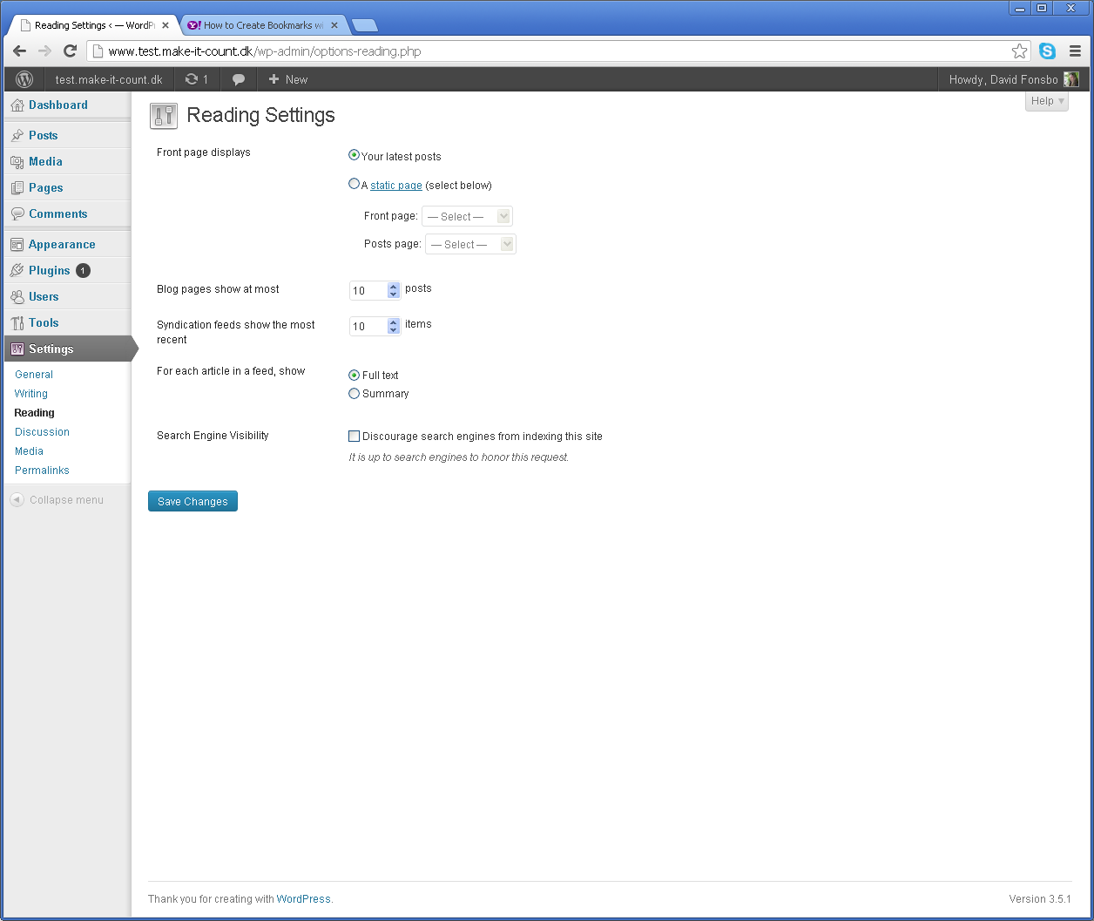
All in all you have as many Pages as you want and only one blog page. Pages are normally fairly static and the Blog page is where you post your statements to everybody on the web. Blogposts are rolling so the last one published is at the top.

Blog pages show at most

Select how many posts you want to be shown.

Syndication feeds show the most recent

Sdfh jkdfh klsj hksljf

For each article in a feed, show
Simply select if you want the full text shown or just the first few lines.

Search Engine Visibility
If you are posting secrets you don't want anybody to know,then check this box. On the other hand if you want help from the searchengines to make your articles known to others then don't check this.

And again: Remember Save!

Setings/Discussion
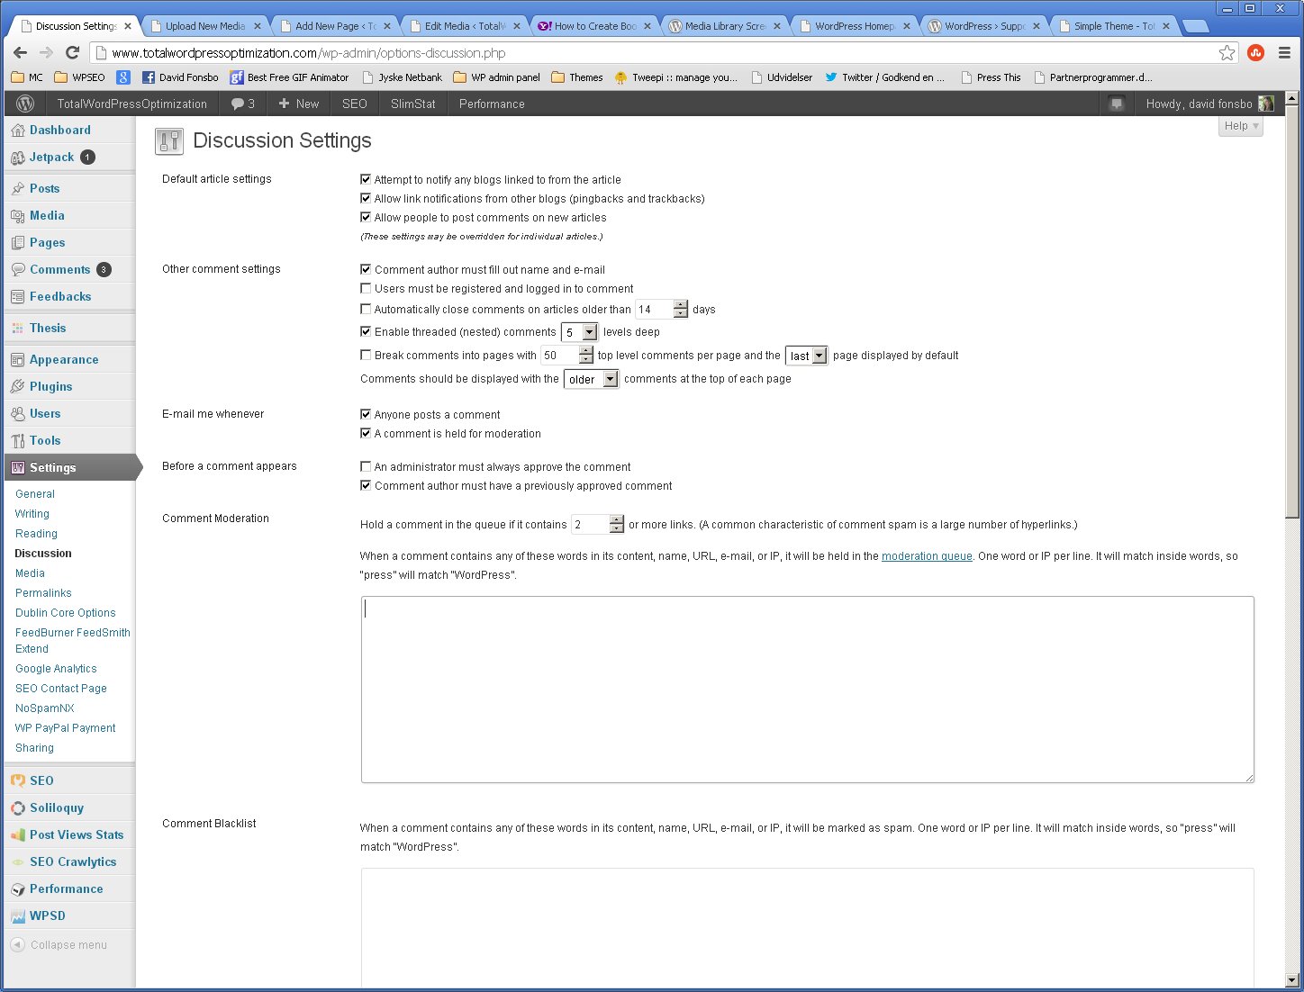
Default article setting.

Attempt to notify any blogs linked to from the article. If you link to another site or post and you check this box, WordPress will send out a ping to those sites or articles. Then your mention of their site or article will show up in the comment section of their site, if that site allows pingbacks.

Allow link notifications from other blogs (pingbacks and trackbacks) Accepts or decline pings from other sites which reference your site or an article on your site. If you check this box, pingbacks and trackbacks will appear in the comments section of your posts.

Allow people to post comments on new articles. If you wish to allow comments to your posts. This can be overridden for individual articles using Quick Edit.

Other comment settings.

Comment author must fill out name and e-mail.
Force the commenters to leave name and e-mail. Spammers will often simply enter a fake mail addres as it is not checked.

Users must be registered and logged in to comment
Only registered users may comment and they have to be logged in.

Automatically close comments on articles older than [X] days
If you for some silly reason don't want any comments after a period of time, check this.

Enable threaded (nested) comments [X] levels deep
Be aware that your Theme might not support this function.

Break comments into pages with [X] top level...
A more structured way to format/setup comments.

Email me whenever

Anyone posts a comment
Note that when your blog gets known you will get a lot of spammail too.

A comment is held for moderation
If you want to review comments before posting them.

Before a comment appears

An administrator must always approve the comment
The comments will not be visible until approved by an Administrator.

Comment author must have a previously approved comment
If a commenter has been accepted before it is not neccesary do do it again.

Comment Moderation

Hold a comment in the queue if it contains...
If you don't want links in your comments or want to control how many then set a default threshold here. If more than X links then hold comment until Moderator has accepted them.

When a comment contains any of these words
You can do the same for words. If the word “sell” is found in the text or link then hold the comment for moderation.

Comment Blacklist

When a comment contains any of these words...
If specific words are found in the comment they will simply be marked as spam.

Contact

This is it folks! Go ahead now. Try it and see if it works for you. If you have any questions or if you think that something in this manual is not clear, you can contact me here:


David Fonsbo

www.Make-It-Count.dk
David@Make-It-Count.dk

Tel. +45 28 94 68 00

Aarhus, Denmark

Resources

General test:
http://www.IsMyBlogWorking.com

HTML test:
http://www.Validator.w3.org

WordPress Help
http://wordpress.org/support/

Other products by me

If you are interested in how to get your WordPress site well positioned in the searchengines, this is exactly what you will need. It is deep stuff and you should at least have a basic understanding of WordPress and a wish to be found by more people on Google, Yahoo, Bing etc.

www.Make-it-Count.dk/TotalWordPressOptimization

It does matter how you design your site and there is a lot of dos and don'ts in this. There is also a dark side to the sales psychology as most people can be influenced subconsciously. To read and use this you must have high standards and ethics.

www.Make-it-Count.dk/WebsitePsychology

This is one of the best written Mindfulness ebooks on the Internet. It covers everything from beginner to very advanced training. It will get you started simple and easy. If you want a life with less stress and more awareness this is a must!

www.MindfulnessTrainingForAll.com
www.HowToBeMindful.MindfulnessTrainingForAll.com

Here is a mindfulness exercise manual to help you if you want a closer relationship with your kids. 12 exercises for you and your kids that you can do together. You are the one to bring more harmony into your kids life. And your own! Here is how to do it.

http://familyness.org/


That's it folks!

