

Download, Prepare, Upload, Installation and Basic Setup

First edition 01.02.2013 by David Fonsbo

Content of this book

Content of this book 2
Legal Notice 3
Introduction 4
Prerequisites 5
Download WordPress 9
Prepare Installation 12
Upload WordPress 14
Create Database 16
Installation 17
Contact 24
Resources 25
Other products by me 26

Legal Notice

The Publisher has strived to be as accurate and complete as possible in the creation of this report, notwithstanding the fact that he does not warrant or represent at any time that the contents within are accurate due to the rapidly changing nature of the Internet.

While all attempts have been made to verify information provided in this publication, the Publisher assumes no responsibility for errors, omissions, or contrary interpretation of the subject matter herein. Any perceived slights of specific persons, peoples, or organizations are unintentional.

In practical advice books, like anything else in life, there are no guarantees of income or any other results made. Readers are cautioned to rely on their own judgment about their individual circumstances to act accordingly. Think for yourself.

This book is not intended for use as a source of legal, business, accounting or financial advice. All readers are advised to seek services of competent professionals in legal, business, accounting, and finance field.

In short: Use your common sense and your brain.

You are encouraged to print this book for easy reading, but you cannot copy, redistribute or sell this ebook. Neither in whole nor detail.

Introduction

Thank you for downloading The Simple WordPress Installation Guide!

WordPress has become a very widely known Content Management System for web sites. It is free and easy to use and with the information in this book you can create your own web site.

WordPress is easy to use. It handles text and images very easy and if you want to optimize for searchengines WordPres is definitely the way to go!

You can find tons of templates for WordPress on the web. This means you can completely redesign Your site in less that a minute!

In this guide you will learn:
- How to download WordPress.
- How to Install WordPress.

Prerequisites

Before trying to download and install WordPress, make sure you have the following:

- A computer (of course!) running Windows XP, Windows Vista, Win7, Win8 or newer).
- Your access codes from your hosting provider. You need codes for FTP access and database (some kind of SQL) access.
- Maybe you need Winzip. But don't worry now. We will come back to this
- Hosting. You need somewhere to upload your WordPress installation. You need hosting. You can choose to host it yourself which this manual does not cover, or you can buy hosting from a hosting company. They will supply you with diskspace, an SQL based database, a control panel and some access codes.

- Some kind of FTP software. I prefer FileZille as it is very easy and very FREE! Go to http://filezilla-project.org/download.php and download the latest stable FileZilla for Windows. There usually is a big green button and there is a link like this (the version number 3.6.0.2 changes): FileZilla_3.6.0.2_win32.zip Use which ever you want.

If you download using iExplorer you get this:

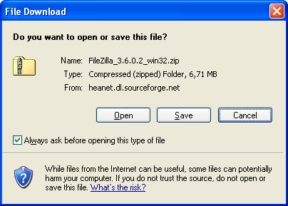
Click save and chose a location. It could be My Computer, Select C: and next Program Files. (Or any other place you like – just remember it for later use).

It might also look like this:
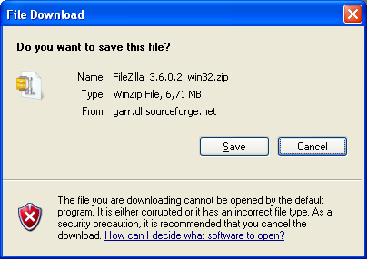

Click Save and select a location and you get this:

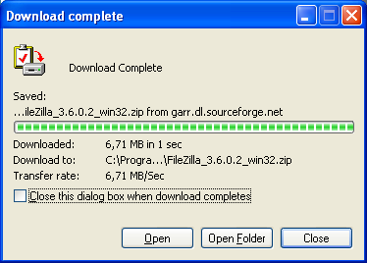

Click Open Folder and you get something like this.

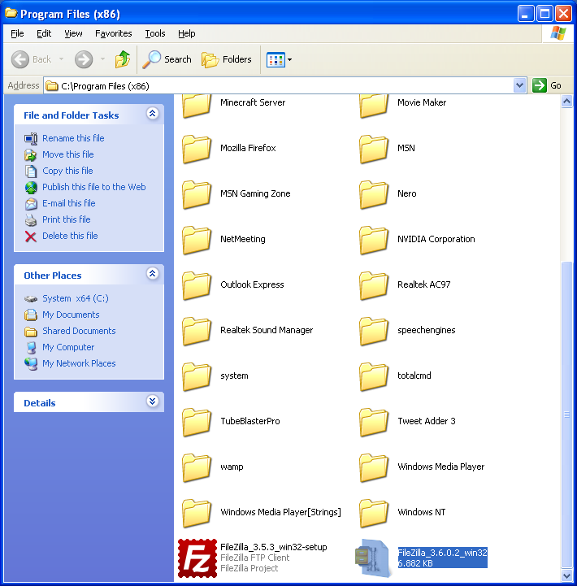
Double click the red Filezilla icon and go with the instructions. FileZilla is now installed.

Download WordPress

There are thousands of sites offering download of WordPress, but the only true source of download is http://wordpress.org/download/.

If you want WordPress in another language you should perform a google searcn something like: “download wordpress germany”. Then you can find the local WordPress website and download the localized version.

You can download it as a normal .zip file or as .tar.gz. It is the same WordPress but in two different containers.

Zip is generally for Windows and tar is generally for Unix systems.

I presume you are on a Windows platform and then you just click the blue button (Download WordPress 3.x) and save the file somewhere on your harddrive you can remember. Let's assume you save it in the directory called “Downloads”. It will be saved as “wordpress-3.x.zip” where 3.x is the version number which changes regularily.

Normally Windows can unpack a zipped file, but if not you have to go to: http://www.winzip.com/downwz.htm and download and install WinZip.

Here area few examples on how it might look. Computers are differently setup so it might look different in your Windows.

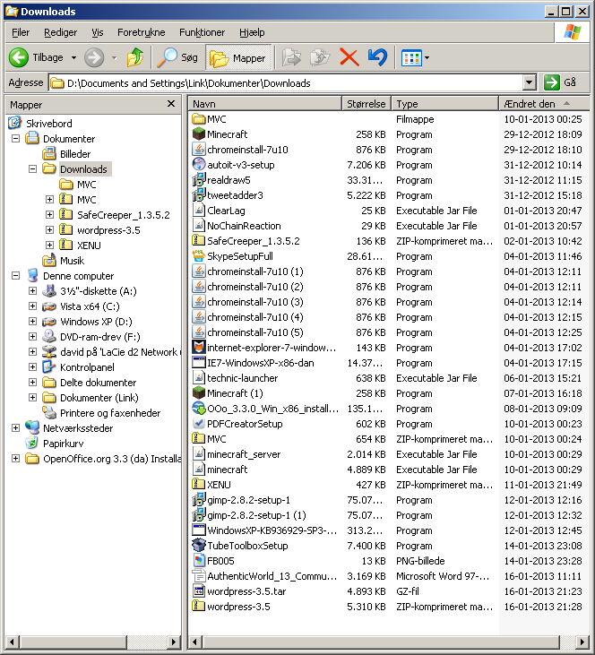

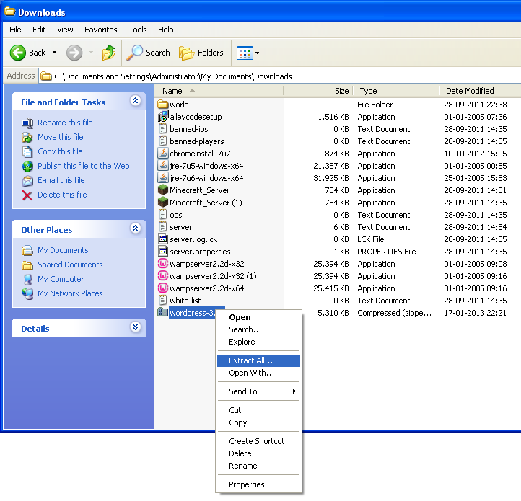
In both of these images we have located the download directory and the last image shows how to Right Click and Extract files form the Zip archive.

After this Windows will ask for a location and I know that I would save my unpacked and almost ready Wordpress installationfiles in a place where I can find them easily so I enter “C:\wp” (without “”) and click finish.

Prepare Installation

So we have to open FileExplorer and find C:\wp (or whatever you chose to call it).

From the File Explorer it would look something like this:

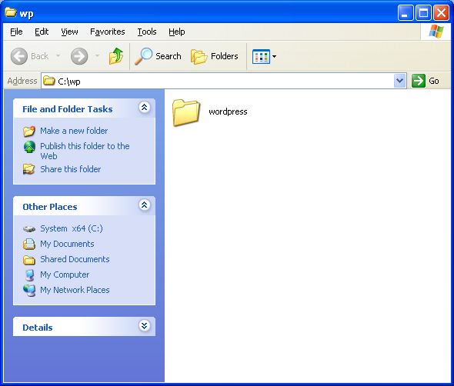

Or this:
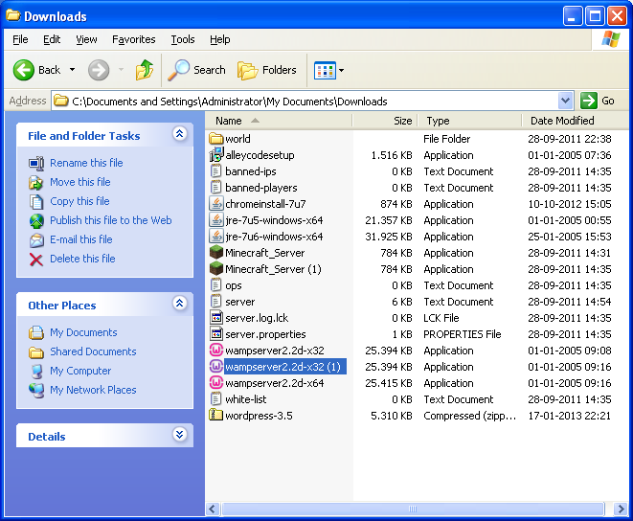

Easy! Right?

Upload WordPress

You need some kind of FTP program to upload WordPress. In this example we will use Filezilla. You can se the details in the Prerequisites chapter.

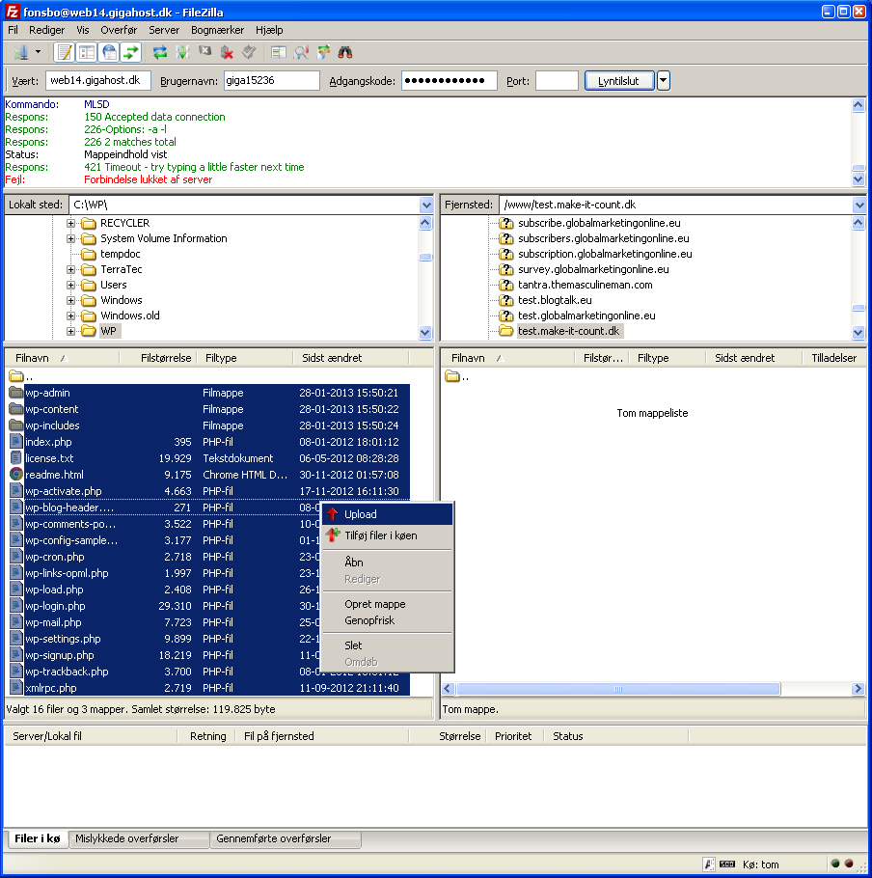
In the first box (where I have entered: web14.gigahost.dk) you have to enter the address of your host.

In the second box you enter your user name as provided by your hosting company.

In the third box you enter your password as provided by your hosting company.

In the fourth box you enter the port number as provided by your hosting company. If you don't have any you can try port 21 which is default for FTP connections.

Click Connect.

If you encounter problems check under Settings/FTP that you are using the appropriate mode. (Passive mode is recommended).

In the left column I have selected the WordPress folder (c:\WP). And In the right Select all files (Ctrl + A), right click and click Upload.

The upload will take a few minutes.

Create Database

The process is different at different companies, and some hosting companies has the database created for you in which case you will have received information including the database name and you can skip this chapter.

If not you have to login at your hosting company using the credentials provided by them and create your own database.

In general you login, go to your database administration, create a database and in some cases also a database user.

There will be a “Create new Database” button or link somewhere. After clicking this you will be prompted for Database name and Password which you enter. The process is very simple.

Your hosting company can provide help or you can find more help here: http://codex.wordpress.org/Installing_WordPress.

Your hosting company is the only one that has the exact information on how to do this, so contact them if you are in doubt.

WordPress describes different processes and you should be able to find one that matches your needs.

Installation

Now you have uploaded WordPress and to proceed with the installation you open a browser and enter the name of your site:

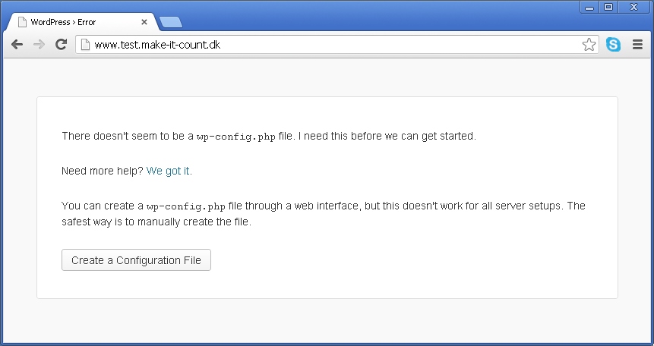

Click “Create a Configuration File”. Then you will see this:
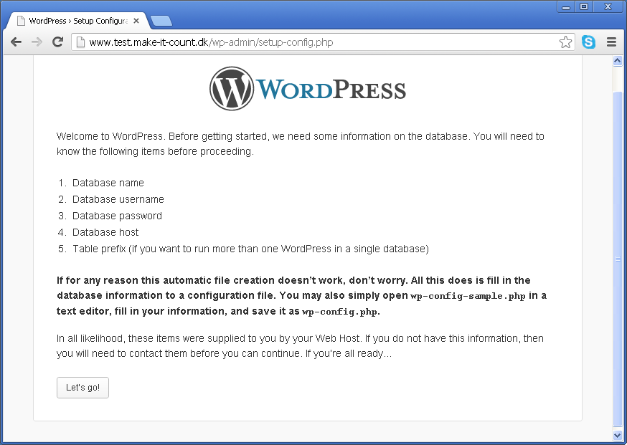
Make sure you got:
- Your database name.
- Your database username.
- Your database password.
- Your database host url.
- Your table prefix if you want to run more than one installation in a single database. If you want a little more security use something else than WP_ and use a databasename that isn't obvious.

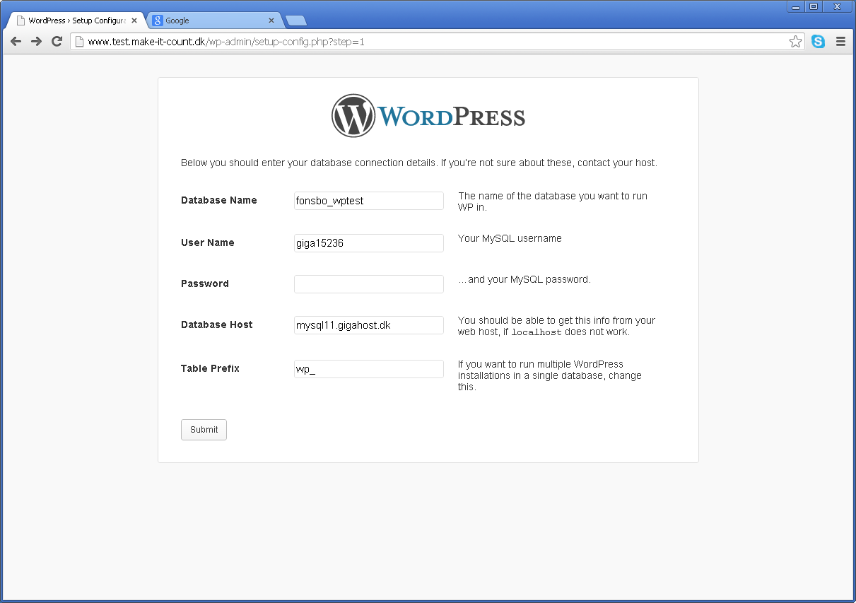
My provider demands a prefix on my database (fonsbo_) which I have to enter. Enter your database credentials here and leave the Table Prefix as it is (WP_).

(You have one database and this database contains a number of tables.)

Click submit.

If everything was entered correctly you get this:

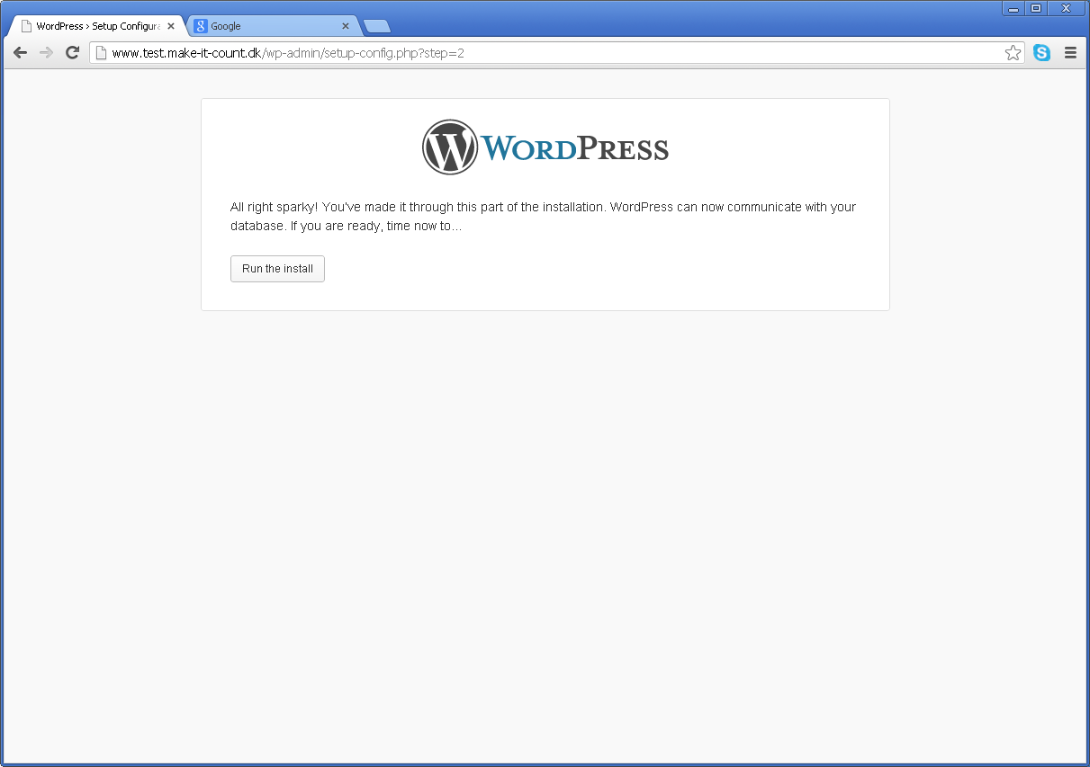
And you click “Run the Install”.

Next you will see this:

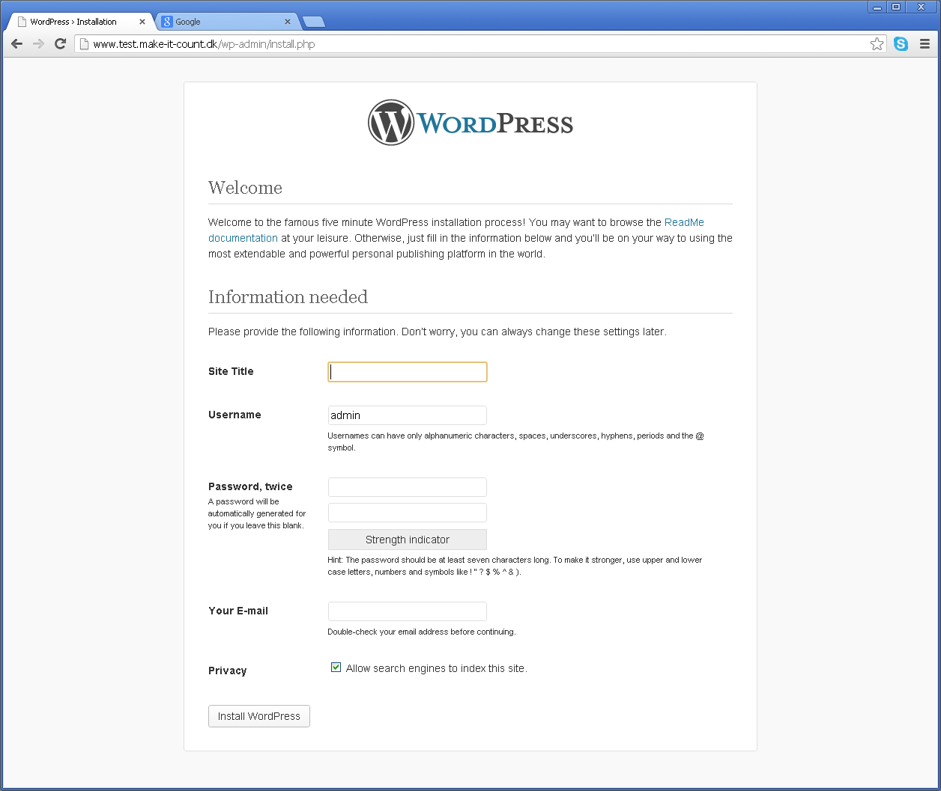
Here you enter the name of your site (You can always change this later) and you have to create your first homepage user. I recommend you do not use Admin. This will make it easier for hackers as this is the first name they will try. Remember to enter your email.

And we are ready to login!

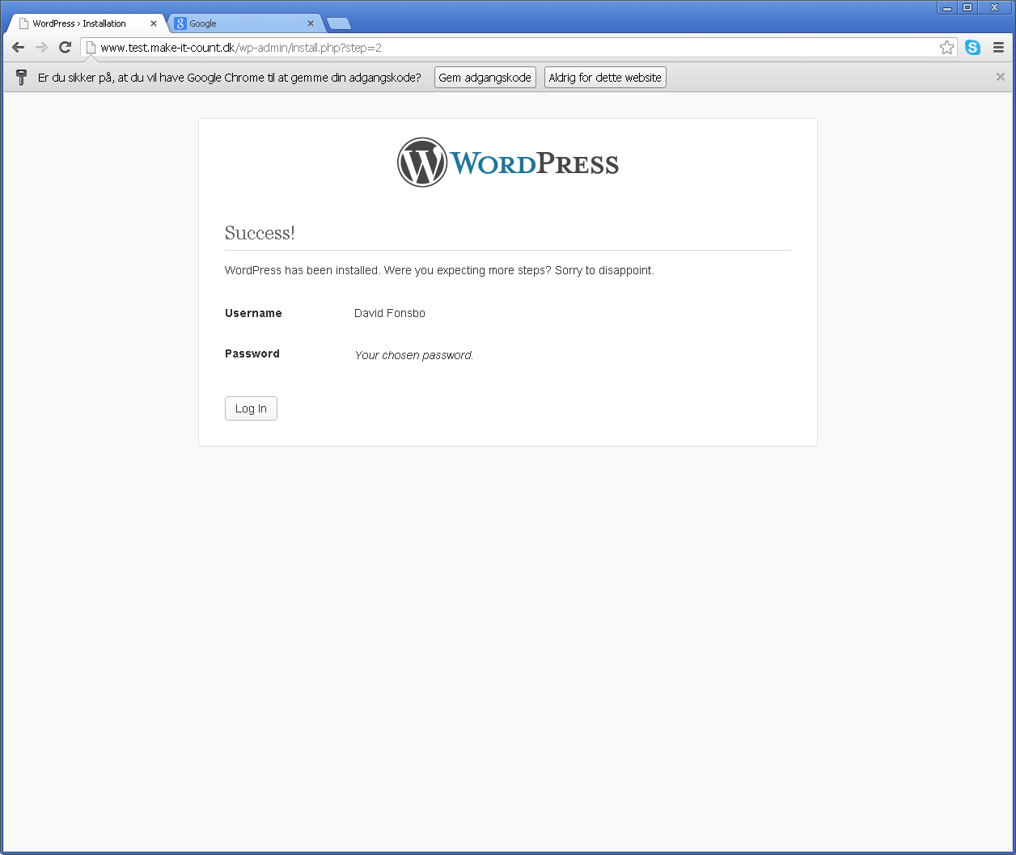
Click Login and you will se the standard WordPress login page:

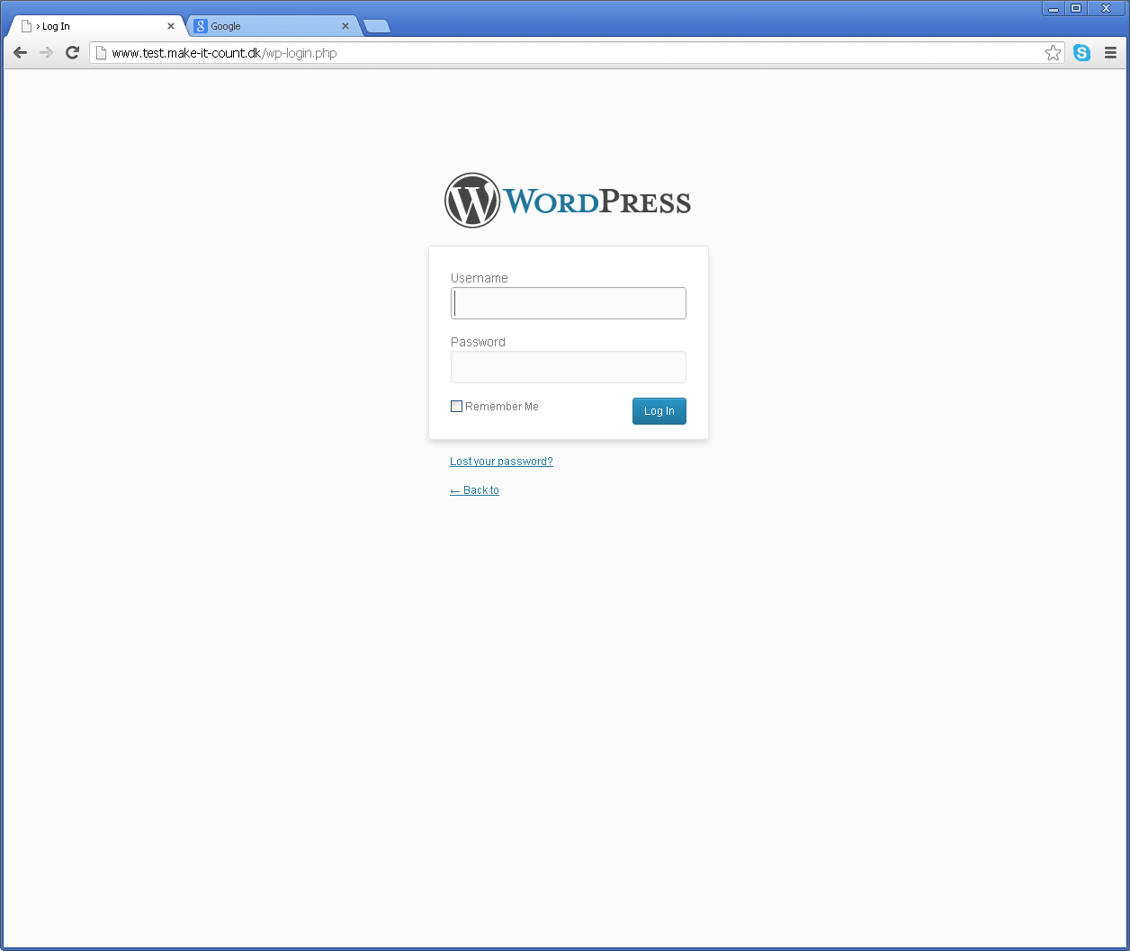
Here you enter the name and the password of the user you just created here.

IMPORTANT:

When you login to WordPress you can do it by entering your sitename in your browser followed by “wp-admin”:

www.YourDomain.com/wp-admin

Contact

This is it folks! Go ahead now. Try it and see if it works for you. If you have any questions or if you think that something in this manual is not clear, you can contact me here:


David Fonsbo

www.Make-It-Count.dk
David@Make-It-Count.dk

Tel. +45 28 94 68 00

Aarhus, Denmark

Resources

General test:
http://www.IsMyBlogWorking.com

HTML test:
http://www.Validator.w3.org

WordPress Help
http://wordpress.org/support/

Other products by me

If you are interested in how to get your WordPress site well positioned in the searchengines, this is exactly what you will need. It is deep stuff and you should at least have a basic understanding of WordPress and a wish to be found by more people on Google, Yahoo, Bing etc.

www.Make-it-Count.dk/TotalWordPressOptimization

It does matter how you design your site and there is a lot of dos and don'ts in this. There is also a dark side to the sales psychology as most people can be influenced subconsciously. To read and use this you must have high standards and ethics.

www.Make-it-Count.dk/WebsitePsychology

And here is one of the best written Mindfulness ebooks on the Internet. It covers everything from beginner to very advanced training. It will get you started simple and easy. If you want a life with less stress and more awareness this is a must!

www.MindfulnessTrainingForAll.com
http://www.howtobemindful.mindfulnesstrainingforall.com/

Here is a mindfulness exercise manual to help you if you want a closer relationship with your kids. 12 exercises for you and your kids that you can do together. You are the one to bring more harmony into your kids life. And your own! Here is how to do it.

http://familyness.org/


That's it folks!

